American International University- Bangladesh (AIUB)

**Thesis**

**Learning through e-Learning in Pandemic**

**Submitted By**

|  |  |
| --- | --- |
| 18-36552-1 | Nafia Alam |
| 18-38458-2 | Arindam Dey |
| 18-38401-2 | Md Sazzad Hossain |
| 18-38311-2 | Umma Khadiza |

Department of Computer Science

Faculty of Science and Technology

American International University Bangladesh

January 26, 2021

|  |
| --- |
| **Declaration** |

We declare that this project is our original work. No part of this has been submitted elsewhere partially or fully for the award of any other degree. Any material reproduced in this project has been appropriately acknowledged.

We declare that this project does not contain any content that discloses the secret of any organization or related parties. American International University-Bangladesh (AIUB) will not be held liable for any such activity, as the project is presented as our original work.

 

|  |  |
| --- | --- |
| _______________________________  **Nafia Alam**  18-36552-1  BSc. in CS  Department of Computer Science | _______________________________  **Arindam Dey**  18-38458-2  BSc. in CSE  Department of Computer Science |
|  |  |
| _______________________________  **Md Sazzad Hossain**  18-38401-2  BSc. in CSE  Department of Computer Science | _______________________________  **Umma Khadiza**  18-38311-2  BSc. in CSE  Department of Computer Science |

|  |
| --- |
| **Approval** |

The thesis titled “**Learning through E-Learning in Pandemic**” has been submitted to the following respected members of the board of examiners of the department of computer science in partial fulfillment of the requirements for the degree of Bachelor of Science in Computer Science on (date of defense) and has been accepted as satisfactory.

|  |  |
| --- | --- |
| _______________________________  **M. Mahmudul Hasan**  Assistant Professor and Supervisor  Department of Computer Science  American International University-Bangladesh | _______________________________  **Sajib Hasan**  Assistant Professor and External  Department of Computer Science  American International University-Bangladesh |
| _______________________________  **Dr. Mahbub Chowdhury Mishu**  Head (Undergraduate Program)  Department of Computer Science  American International University-Bangladesh | _______________________________  **Professor Dr. Tafazzal Hossain**  Dean  Faculty of Science and Technology  American International University-Bangladesh |
| _______________________________  **Dr. Carmen Z. Lamagna**  Vice Chancellor  American International University-Bangladesh | |

|  |
| --- |
| **Acknowledgment** |

This project is our cordial effort and supervisor's initiative and constant motivation. But First of all, we would like to be grateful to the Almighty Allah, who gave us the effort to work on this project for the last semester. Especially thanks go to our honorable supervisor M. Mahmudul Hasan faculty member, American International University-Bangladesh [AIUB], for this enormous support, inspiration, and helpful criticism. His excellent supervision and constant support make this project possible. We are very grateful to him for allowing us to work with him. We also convey our thanks to our honorable Vice-Chancellor, Dr. Carmen Z. Lamagna, our Dean, Prof. Dr. Tafazzal Hossain, our Associate Dean, Mashiour Rahman, our Director, Dr. Dip Nandi, and our Head of Department, Dr. Mahbub Chowdhury Mishu, for their constant motivation and support.

Last but not least, we thank our respectable parents for educating us with aspects from both arts and sciences, for their unconditional support and encouragement to pursue our interests, even when claims went out of boundary.

**TABLE OF CONTENTS**

**Thesis Summary** 6

**Keywords** 7

**CHAPTER 1: INTRODUCTION** 8

**1.1** **Learning through E-Learning in Pandemic** 8

**1.2 Thesis Background/Problem Analysis** 10

**1.3 Research Motivation and Objective** 12

**1.4 Literature Review of Existing studies** 14

**CHAPTER 2: RESEARCH METHODOLOGY** 17

**2.1 Conceptual Framework** 17

**2.2 Data Collection Method** 18

**2.3 Ethical Issue** 19

**CHAPTER 3: PROJECT/THESIS PLAN** 21

**3.1 Thesis Effort Estimation** 21

**3.2 Thesis Planning** 22

**3.3 Uncertainties and Risk Analysis** 23

**3.4 Thesis Execution** 23

**CHAPTER 4: RESULTS AND ANALYSIS** 25

**4.1 Solution Description** 25

**4.2 Impact on Environment** 28

**4.3 Lifecycle Analysis** 30

**4.4 Solution Verification** 32

**CONCLUSION** 36

**REFERENCE** 36

**APPENDIX** 40

# **Thesis Summary**

Issues about favorable execution, organization, and achievement of e-Learning systems have attracted numerous researchers. Nonetheless, models and frameworks are still insufficient in research on e-Learning addressing authoritative aspects alongside teacher and student aspects. Therefore, the motive of this research was to discover the elements of success and the problem and solution of e-Learning. A grasp of the components of e-Learning achievement is fundamental for the improvement and conveyance of good e-Learning resourcefulness. As students have been introduced to e-Learning in this Pandemic for the first time with great importance as this has become the new worldview in education, students have faced various problems and challenges whose solutions are yet to be discovered. Some of the significant issues have been discussed in this research paper in depth. However, e-Learning has immense benefits, which definitely outweigh the drawbacks it comprises. The most considerable problem online learning has is devices scarcity and crashing systems. Not each and every student or instructor owns a personal device with which they participate in e-learning. Another issue that everyone has encountered is a computer crash, which typically occurs at the most inconvenient time. Moreover, another issue is connectivity. Because of the widespread use of online learning systems, platforms are overburdened. Computer literacy is another problem to consider as a minority of people are not entirely familiar with utilizing digital tools. Hopefully, the solutions provided will help in the better usage of online learning for both teachers and learners. The main focus of our thesis paper is the effectiveness of e-Learning. The main objective of our research is to utilize the efficient way to learn through e-Learning in Pandemic. The questions we focused on are “Does the system give the proper and precise results for both teacher and student?” “What are the challenges of online teaching & learning through the covid-19 pandemic?” “What are some major limitations of using an e-Learning system?” We discovered vital influencing elements as well as numerous study design types. There are various conceptual models to conduct research. The appropriate conceptual model we considered for our study in this thesis is Design Science Research Methodology (DSRM), as DSRM contains necessary procedures and principles to conduct scientific research through investigating prior literature. Every six-step of the DSRM process are elaborately explained in this paper. We selected survey as our data collection method. The students were provided with polls where they were asked to agree or disagree with points provided about the problems and satisfaction of using e-Learning. They were asked if they were satisfied enough and had learned as much as they would have in offline classes, whether the teachers and institutions were helpful and considerate, etc. There are specific ethical issues, too, which we discussed in Chapter 2. The survey we conducted showed that approximately 80% of the students are somewhat satisfied with the e-Learning system. The drawbacks the system possesses are taken into consideration, and solutions were presented duly.

# **Keywords**

e-Learning in Pandemic; Technology benefits; DSRM process; Survey results; Problem and solution; Impact on the environment; e-learning effectiveness

|  |
| --- |
| **CHAPTER 1: INTRODUCTION** |

# **Learning through E-Learning in Pandemic**

E-Learning refers to gaining knowledge through the use of a range ofdigital resources, particularly technologies involving the internet (Ozkan & Koseler, 2009). As indicated by Rosenberg (2001, p. 28), the three essential criteria for e-Learning are that it is networked, delivered to the end-user through a computer using the internet, and it is mainly based on the broad view of learning that goes past the traditional paradigms of learning and teaching.

The rise of the massive number of e-Learning systems is, in fact, one of the most significant improvements in the IT industry over the past 15 years (Wang & Shee, 2007). Hence, the everyday context of schooling has experienced drastic changes with the arrival of e-learning (LeePost, 2009). The advantageous use of IT in education is seen as having the capability to enhance the high-quality of learning and as access to education (Gilbert, Morton, & Rowley, 2009). E-Learning takes into account the developing and assorted learning requirements. E-Learning has emerged as the new worldview in education due to the fact of its ease, decrease in expenses, as well as adaptability. The effectiveness of the cost of e-Learning was emphasized as an advantage for higher education and the system. Rosenberg (2001, p. 30) identified cost-effectiveness, accessibility anytime and at any place, having the ability to access global educational resources for the highest skill development, building networks, and offering valuable customer service as various advantages of e-Learning.

Various institutions of higher education are prompted to present creative e-Learning programs by extending their limits on education. Nonetheless, the improvement of successful e-Learning systems is pretty tricky for higher education institutions and business organizations on account of the amount of funding needed and because of the uncertainty of the consequences (Govindasamy, 2002). Hence, a perception of the components of e-Learning achievement is fundamental for the improvement and conveyance of effective e-Learning initiatives (Lee & Yoon, 2009).

The vast funding and speedy popularity of e-Learning inspired researchers to research the accomplishment of e-Learning systems and the problems associated with their execution. A wide variety of researchers have tried to use measures such as user satisfaction, consumer acceptance, and effectiveness of e-learning. Nonetheless, there is no definition for e-Learning systems achievement that is globally accepted.

According to a survey taken, students of various different schooling institutions have shared their opinion on the effectiveness of e-learning. The students were also asked how helpful their teachers have been while studying online.

Various researchers have studied e-Learning systems, like Management Information Systems, Education, and Psychology. Nevertheless, a maximum number of e-Learning research till now depended on a local perspective on the success of e-Learning systems, with most analyses using a single success dimension. There are e-Learning systems success studies in addressing systems success as multi-dimensional, where the dimensions affect one another. However, these researches center around one kind of stakeholder, in particular, students. No structures of e-Learning systems success represent more than one partner by combining organizational, instructor, and learner dimensions. Despite the fact that there are a massive variety of trials by preceding researchers to emerge and test e-Learning systems achievement, the quantity of research is limited.

# **1.2 Thesis Background/Problem Analysis**

## Statement of the research problem:

## As a consequence of its growth, COVID-19 has forced millions of students and educators to modify their contact information online. We must adapt to a new way of life since schools have been closed till further notice. Teachers and administrators are working hard to keep students on track and adapt to online learning as fast as possible during the lockdown.

## Gadgets shortage & crashing systems: Online learning can't be done by everyone since not everyone has access to a personal computer or mobile device. Students are asked to share laptops and computers with their family members in order to stay on track. Computer crashes are another common occurrence, and they always happen at the worst possible times**.**



Figure 1:Gadgets shortage & crashing systems (collected from Deposit Photos)

## Connectivity: Millions of people across the globe are experiencing technical difficulties as a result of the extensive use of digital technologies such as online learning systems, video streaming software, and others. Low-quality video and audio, as well as problems with the internet, plague the platforms. The internet connection is either inconsistent, or the current data plan is inadequate to fulfill the growing e-learning needs. There is a "homework gap" that affects both urban and rural kids. Teachers are doing their best to deal with a sluggish internet connection while students are taking online courses**.**



Figure 2:Connectivity (collected from Coeo Solutions)

## **Computer literacy:** It's difficult for teachers, students, and parents to use a learning management system or any other digital tool straight away without further training. Trying to go digital can leave people feeling daunted and irritated by the sheer volume of data they have to deal with**.**

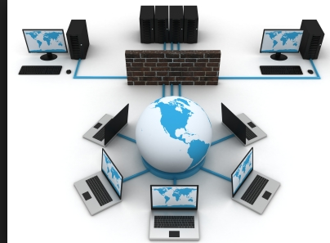

Figure 3:Computer literacy (collected from steemit)

# **1.3 Research Motivation and Objective**

Motivation:

Students suffered social isolation, practical training cancellation, and a general lack of enthusiasm during the COVID-19 epidemic. The teaching problems posed by the unusual scenario were the driving force behind the development of new creative e-learning instances. Basically, E-learning is a technology that is based on education. But what I find more valuable is that it is convenient and a helpful tool; besides, it is used for Healthcare, Technology, Retail and E-Commerce, Education, and Construction. This technology is flexible for users. Its use can reduce the travel cost of n students and can be very cost-effective when it comes to face-to-face programs. Besides, in E-learning, we can use more time at work and less time in learning. So in practical life, it is that effective.

The primary goal of my study is to use E-learning as an efficient method of learning in the midst of a pandemic.

1) Does the system produce accurate and consistent outcomes for both the teacher and the student?

2) What are the obstacles of online teaching and learning in the midst of the Covid-19 Pandemic?

3) What are the primary drawbacks of adopting an E-learning system?

Performance, conditions, and criteria are all potential components of learning objectives, and solutions to these challenges are available. Improve the standard of learning and instruction,

Enhance efficiency and effectiveness. Enhance user accessibility and temporal flexibility to better engage learners in the learning process.

Students are enthusiastic, the course material appears to be engaging, and a public awareness campaign has been begun to ensure that everyone is aware of the opportunity. However, the content's quality isn't quite up to scratch. Course content must be good and of the highest level in today's environment, with hundreds of free online courses and robust platforms such as Wikipedia, YouTube, and Google. Many students, however, become dissatisfied when they realize that they can learn more on their own than they can in the primary, substandard courses given by their employers or schools.

Your job, like the rest of the world, has evolved drastically in recent years. One of the essential responsibilities of the person in charge of training is to identify, select, and prioritize the finest courses. As a result, only go for the best.

Teachers and students are the users who are being targeted. The primary benefit of this method is that students will always learn about current events.

Sustainable development is typically linked to real-world issues, and it necessitates researchers aligning scientific knowledge generation with genuine society problems.

We administered a questionnaire of land use–related initiatives using grounded theory methodologies to investigate how academics characterize scientific contributions when formulating and organizing programs.

Investigators uncovered significant contributing factors as well as a variety of research design styles.

Scientific concerns were shown to be more critical than predicted among the elements that impact project framing. The main characteristics of project framings were (a) the sort of scientific contributions that were expected, (b) the real-world sustainability issues discussed, and (c) the investigator's estimates as to how the information would be delivered to its intended receivers Sustainable development research aims to initiate or promote social change that is focused on sustainability. It aims to broaden our knowledge and understanding in order to rethink how we satisfy our requirements. As will be discussed further below, the stage of developing projects and selecting research topics has a significant impact on the societal relevance of research. As a result, we investigated how academics effectively connect notable advancements to economic development at the design and planning stages and how they direct the content of their activities toward real-world problems. When defined as a study aimed at promoting long-term growth by determining whether or not change is required and, if so, how it may be achieved. Despite the fact that the projects came from many fields and addressed a wide range of sustainability issues, they all contained three categories of scientific contributions: Researchers hoped to get a better basic knowledge of particular processes, as well as outline sustainable resource use patterns and determine precise criteria in certain situations. The descriptions of the difficulties, especially the most unique aspects of these descriptions, were stressed for assessing the sustainability challenges the research projects alluded to. The fact that issues are manifested, identified, and handled in the actual world has proven to be an essential aspect. The challenges are divided into two categories: those that are still being determined by individuals and those that have been widely acknowledged and have rather apparent solutions to be implemented—virtually reflecting two extremes of a spectrum (For a more in-depth examination of scholars' perspectives on sustainability, (Wuelser, 2016).

# **1.4 Literature Review of Existing studies**

The success of any data system depends on the usage of the system by users. (Almaiah, M. A. Acceptance and usage of a mobile information system services in the University of Jordan. Education and Information Technologies., (2018)) Thus, within the context of the e-learning system, students' acceptance of e-Learning is taken into account in concert with the most criteria for the success of the e-learning system. Many studies in the literature have self-addressed problems relating to e-learning adoption in several countries over the world. (Almaiah, M. A., & Man, M. Empirical investigation to explore factors that achieve high quality of mobile learning system based on students' perspectives. (2016).).E-learning tools have contended a crucial role throughout this Pandemic, serving colleges and universities facilitate student learning during the closure of universities and schools whereas adapting to the new changes, workers and student readiness should be gauged and supported accordingly. To estimate the university medical employee's perceptions, live their experiences, acknowledge their barriers challenges of e-learning throughout the COVID-19 Pandemic, and investigate factors influencing the acceptance and use of e-learning as a tool teaching among higher education. The Pandemic of COVID-19 caused several faculties and schools to remain quickly closed. Face-to-face education has been completed by various schools, universities, and colleges. This can have negative impacts on educational activities, as the social distance is crucial at this stage. Instructional agencies are attempting to search out alternative ways to manage this troublesome circumstance (Dhawan S. Online learning: A panacea in the time of COVID-19 crisis. J Educ Technol Syst. , 2020;). This ending stirred up the expansion of online instructional activities in order that there would be no interruption to education. Several schools are concerned about, however, best to supply online course material involving students and perform evaluations (Mukhtar K, Javed K, Arooj M, Sethi A. Advantages, Limitations, and Recommendations for online learning during COVID-19 pandemic era. Pak J Med Sci Q., 2020). The learners with a tough and quick outlook realize it troublesome to adapt and adjust, whereas the learners with a growth mindset quickly adapt to a replacement learning environment. There's nobody size-fits-all pedagogy for pandemic E-learning. There is an unfolding of subjects with varying needs. Completely different subjects and age teams need different approaches to E-learning- learning additionally permits physically challenged students with additional freedom to participate in learning inside the virtual environment, requiring restricted movement. First of all, there are a few obstacles to the E-learning system, for example, technical limitations. To apply E-learning gadgets, college students want necessary hardware like laptops or phones. E-learning is turning into a crucial device for academic purposes. E-learning gadget is powerful in records and era for learning and coaching purpose. The maximum influential motives for E-learning presently have been e-learning structures and requiring an excessive degree of records era from instructors, college students, and universities. E-learning may be completed anywhere. It ends in greater bendy surroundings for college kids, but for the use of E-mastering gadgets, one should be related to the net. But maximum of all E-learning gadgets is a whole lot greater less expensive than conventional techniques of coaching. Researchers have already evolved this gadget for learning purposes. But I personally discover a few downsides due to the fact learning from individual to individual is greater green than mastering in an E-learning system. For instance, whilst a pupil is mastering immediately from an instructor, the pupil won't apprehend a few subject matters; for this reason, he can clean the one's subject matter with the aid of using asking the instructor. But for an E-learning system, this could now no longer be viable, and if viable, the solution to the query is probably not on time for a few reasons. But in this pandemic scenario, the E-learning system is supporting a lot. But there are numerous factors like robust and susceptible factors on this E-learning system. The use of E-learning systems is growing 12 months after 12 months for its efficiency, value green, and for net accessibility.Studies were accomplished to peer the hobby of the scholars approximately E-learning, and the end result have as a wonderful site. The college student’s hobby, approximately E-learning, was on surge (Basilica &Kvavadze, 2020) (Basilica &Kvavadze, 2020). According to the Technology Acceptance Model, perceived application and perceived ease of use are the two maximum important figuring out variables for era acceptance.Though there are a few troubles like E-learning turned into now no longer the formal mode of schooling earlier than the pandemic scenario (Guribye, F. and Netteland, G., 2003). But now, there are not of any higher manner for mastering besides E-learning. Unlike conventional coaching techniques, the educational content material in e-learning isn't decided with the aid of using the instructor or any organization, and it would help college students in acquiring their personal information requirements. However, research additionally showed that perceptions of novices place tormented by a bunch of factors (Elena R. V.; Anna V. M.; Suriya I. G.; Evgeniy M. D.; Vladimir V. E., 2020). The observation is greater powerful due to the real-international context. The important purpose of shifting information is to make sure that the pupil comprehends the cloth and might observe it in real-international settings. This explains why the pupil is in the middle of the development principle. The instructor serves because of the coordinator or proposal of the entire academic process. E-learning technology is being utilized by academic establishments to enhance communication among college students and instructors, in addition to constructing the mastering network as a way to attain personal goals (Yoon, J., Yang, E., Lee, J. and Hwang, S. J., 2017). Also, the flexibility of E-learning also can be an answer for people’s commitments for their own circle of relatives or work. Thus it could boom the range of those who sign up for this kind of schooling on this pandemic scenario.

|  |
| --- |
| **CHAPTER 2: RESEARCH METHODOLOGY** |

# **2.1 Conceptual Framework**

There are various conceptual models to conduct research. The appropriate conceptual model we considered for our study in this thesis is Design Science Research Methodology (DSRM). DSRM comprises necessary procedures to conduct scientific research through investigating prior literature in order to provide a supposed process model of studies and also provide an intellectual model of evaluation and presenting research outcomes in the information system domain. DSRM has been adopted and evaluated in several Information System research that provides a supposed process model for doing research and also provides an intellectual model for presenting and assessing solutions of the study (Hevner & Chatterjee, 2010), (Peffers et al., 2006), (Peffers et al., 2007), (Hasan, 2021).

In the DSRM process, there are six systematized steps to be followed to conduct research, as shown in Figure 2.1.1. The initial step is to perceive problems and encourage and show the importance of the study. This step is explained in sections 1.2 & 1.3 (Chapter 1). The second step is to define the objective of a solution what would a better artifact accomplish. This is discussed in section 1.3 (Chap 1). The next step is the design and improvement of the artifact, which is shown in Chapter 4. The next step is demonstration. Here, we had to find a proper context and use the artifact to solve problems. The fifth step is evaluation. Here, we had to observe the efficiency and effectiveness and iterate back to the design. The very final (6th) step is communication which involves professional and scholarly publication to the related audience. All these are discussed in Chapter 4.

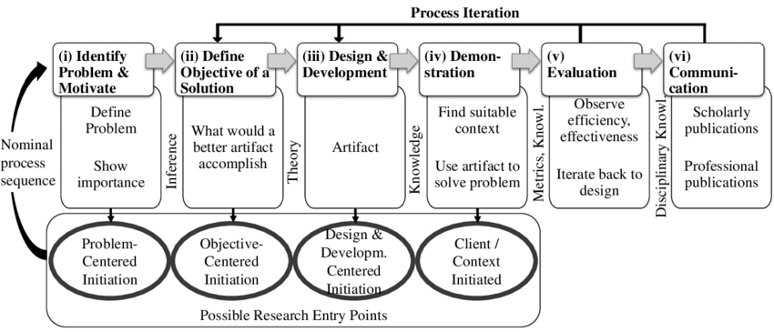

Figure 4: DSRM Process (collected from Research Gate)

# **2.2** **Data Collection Method**

First of all, researchers can acquire a significant quantity of data in a short amount of time via surveys. Many alternative data collecting strategies are more expensive than surveys. Surveys may be used to gather data on a variety of topics, including personal information, attitudes, historical activities, and views. Online surveys, e-mail surveys, social media surveys, paper surveys, mobile surveys, telephone surveys, and in-person interviews are all methods of survey delivery.

Only research questions about the influence of e-learning technologies on people are included, as previously stated. For each of the five factors, we examine the frequency and percentage of replies. The table and the questions are given below;

Questions:-

1: I've learned a lot from my experience with the e-learning system.

2: The e-learning system heightens my understanding of the necessities of educational procedures.

3: Using the e-learning system improves my learning abilities.

4: I am pleased with my experience with the e-learning system.

5: The majority of users have a favorable opinion of or appraisal of the functionality of e-learning systems.

The survey questionnaire was used because it is an efficient data collection method that can be administered to a more significant number of individuals, at a lesser cost and in a shorter time when compared to other forms of data collection (such as interviews) (Samarasinghe, 2012).In this survey, all the participants are university students. And to complete the study, a tool, namely Google form, was used.

# **2.3** **Ethical Issue**

Interview/survey Of the assignment could be carried out as more than one case study (cross-case study). It will validate the proposed framework through back-checking out at the actual life, numerous use instances portfolio; the final results of this segment is a subtle model of framework. After validation via more than one case study, the relevance and software of the framework are to be tested.

Data collection surveys collect information from a targeted cluster of people regarding their opinions, behavior, or knowledge. Common types of example surveys are written questionnaires, face-to-face or phone interviews, focus groups, and electronic (e-mail or website) surveys. There is a survey of ethical issues that should always be thought about once coming up with any form of data assortment. Information collection always prices somebody something. It's going to price health workers' time and energy to complete police work forms. It actually costs the health coordinating organization cash and time to collect, analyze, interpret, and diffuse surveillance data and results. Surveys are even a lot resource-intensive. Information collection additionally costs the folks within the population from which the info is collected an exact quantity of time, discomfort, and potential harm.

In addition, they were implementing or rewriting programmers in response to the conclusions drawn from data collected price workforce, time, money, and alternative resources continually. And if the decisions are wrong as a result of the info being poorly managed, these resources that may be used otherwise could also be wasted or inefficiently employed.

Therefore, before starting the look process, make sure that the results of the data assortment will:

* Actually, be needed,
* Be disseminated widely,
* Be used the minuscule amount of invasive and expensive data collection technique doable.

Transformation to the virtual machine has made existence more effortless, and the recognition of the e-learning machine inside the educational reality of college students is a fact. Therefore, many instructional businesses use the e-learning surroundings for coaching learning activities. The gift examination has been carried out to assess the attention of the undergraduate college students to ethics and to decide if there may be a distinction in step with gender and educational degree variables the use of an e-learning machine. A self- been designed to degree the participant's focus of ethics. It includes 20 objects labeled in 3 moral classes; Intellectual belongings rights, vandalism, and Privacy. The effects display that the attention of college students is low in all three types concerning their dedication to the moral problems whilst the use of an e-learning machine. Result additionally display that there aren't any substantial variations among undergraduate college students' gender and Academic degree associated with the attention of ethical issues. Therefore, undergraduate college students have to be thoroughly knowledgeable approximately ethical issues to keep away from unethical conduct even with the use of the e-learning machine. Despite the advantages of the use of era for college students, it could boom the possibilities of falling into unethical behaviors**.** (Jamil.M.and Shah, J.H., 2014) . The Education Network has a perception that the conventional coaching-learning fashions do now no longer meet the brand new demanding situations created through popping out technologies (Nagi, K., 2006). This examines objectives to assess the student's focus of ethics whilst the use of an e-learning machine for the coaching studying process. It explores if there may be a distinction inside the direction of the ethical issues whilst the use of the e-learning machine is in step with gender and educational degree variables.

Chances for unethical conduct via college students typically take region in e-Learning in preference to conventional studying, led the newbies in e-learning to act unethically (AbdulHafeez, M., Farooq, A., and Asadullah, R., 2015). Ethical conduct is socially and morally acceptable is a correspondent with good doings of the society (Bowden, P., and Smythe, V., 2008). The author in (Cilliers, L., 2017) has achieved a quantitative examination to analyze the ethical issues. The survey highlighted plagiarism, Software piracy, and dishonest effect problems. The creator concluded that ethical issues should be included inside the curriculum whilst the writer observed that scholars are now no longer aware of ethical issues such as plagiarism and software program piracy. Interview/survey Of the assignment could be carried out as more than one case study (cross-case study). It will validate the proposed framework through back-checking out at the actual life, numerous use instances portfolio; the final result of this segment is a subtle model of framework. After validation via more than one case study, the relevance and software of the framework are to be tested.

|  |
| --- |
| **CHAPTER 3: PROJECT/THESIS PLAN** |

# **3.1 Thesis Effort Estimation**

|  |  |  |
| --- | --- | --- |
| Budget Items | Quantity | Amount (TK) |
| Researcher | 1 | 100000 |
| Computer programmer | 1 | 5500 |
| Data Collector | 4 | 6500 |
| Data access | 5 | 3500 |
| Computer use | 4 | 7000 |
| Study Materials | 10 | 5000 |
| Books | 4 | 2400 |
| Total | 31 | 129900 |

Table 2: Budgets of the thesis plan

|  |  |  |
| --- | --- | --- |
| Task | Start date | End date |
| Topic selection and proposal | 10.08.21 | 15.08.21 |
| Discussion with supervisor | 17.09.21 | 19.09.21 |
| Study on topic | 07.09.21 | 16.09.21 |
| Prepare research questions | 23.09.21 | 27.09.21 |
| Literature review | 13.10.21 | 21.10.21 |
| Conceptual framework | 13.11.21 | 20.11.21 |
| Data collection | 13.11.21 | 20.11.21 |
| Effort estimation | 25.11.221 | 01.12.21 |
| Risk analysis |  |  |

Table 3: Timeline of the thesis plan

# **3.2 Thesis Planning**

Gantt Chart:

|  |  |  |  |  |  |  |
| --- | --- | --- | --- | --- | --- | --- |
| Task | August | September | October | November | December | January |
| Topic selection and proposal | August 10 –August 15 |  |  |  |  |  |
| Discussion with supervisor |  | September 17 –September 19 |  |  |  |  |
| Study on topic |  | Sept 7-sept 16 |  |  |  |  |
| Prepare research questions |  | September 23 –September 27 |  |  |  |  |
| Literature review |  |  | October 13 –October 21 |  |  |  |
| Conceptual framework |  |  | October 13 –October 20 |  |  |  |
| Data collection |  |  | October 13 –October 20 |  |  |  |
| Effort estimation |  |  |  | November 11 |  | January 1 |
| Risk analysis |  |  |  |  |  |  |

Table 4: Thesis Planning (Gantt Chart)

As a result, the budget for this project should explain how the totals for each category of costs are calculated. For this project, a total of 189900 takas has been spent. The cost to the researcher was 100000 taka, while the cost to the student who completed the study was 60000 taka. For 5500 taka, a computer programmer was recruited. The rest of the money was also used to bring various instruments, as shown in the table in Chapter 3.1.

# **3.3 Uncertainties and Risk Analysis**

|  |  |  |  |  |
| --- | --- | --- | --- | --- |
| S/N | Risk Description | Probability | Impact | Mitigation Plan |
| 1 | Unrealistic time estimate | 40% | Significant | Take multiple estimations |
| 2 | Possibility of perennial incidents | 50% | Significant |  |
| 3 | Meager support from the teammates | 30% | Significant | Ensure spare support from all |
| 4 | Unrealistic price estimates | 60% | Significant | Take correct estimation |
| 5 | Decisions delay | 40% | Significant | Decision one or two meeting hebdomadally |
| 6 | Real-time overall performance Issues |  |  | Simulation, prototyping, standardization |
| 7 | Unstable internet connectivity | 40% | Significant |  |
| 8 | Technical problems | 32% | Significant |  |
| 9 | Perceived usefulness | 76.5% | Significant |  |

Table 5: Uncertainties & risk analysis

# **3.4 Thesis Execution**

|  |  |  |  |
| --- | --- | --- | --- |
| **Task Name** | **Start Date** | **End Date** | **Duration (days)** |
| Topic selection | 10/8/2021 | 15/8/2021 | 5 |
| Planning | 26/8/2021 | 5/9/2021 | 10 |
| Study on topic | 7/9/2021 | 16/9/2021 | 9 |
| Discussion with the supervisor | 17/9/2021 | 19/9/2021 | 2 |
| Survey question selection | 23/9/2021 | 27/9/2021 | 4 |
| Review question | 27/9/2021 | 27/9/2021 | 0 |
| Survey | 28/9/2021 | 10/11/2021 | 43 |
| Survey Result Collection | 10/11/2021 | 10/11/2021 | 0 |
| Start First Chapter | 13/10/2021 | 21/10/2021 | 8 |
| Review First Chapter | 6/11/2021 | 6/11/2021 | 0 |
| Start Second Chapter | 13/11/2021 | 20/11/2021 | 7 |
| Review Second Chapter | 20/11/2021 | 20/11/2021 | 0 |
| Start Third Chapter | 25/11/2021 | 29/11/2021 | 4 |
| Review Third Chapter | 30/11/2021 | 30/11/2021 | 0 |
| Start Fourth Chapter | 10/12/2021 | 25/12/2021 | 15 |
| Review Fourth Chapter | 28/12/2021 | 28/12/2021 | 0 |
| Summary, Keywords & Conclusion | 6/01/2022 | 9/01/2022 | 3 |
| Final Draft Submission | 10/01/2022 | 10/01/2022 | 0 |
| Final Report Submission | 26/01/2022 | 26/01/2022 | 0 |

Table 6: Thesis Deliverable Plan

|  |  |
| --- | --- |
| Student’s Name | Thesis Work |
| Nafia Alam | 1.1 Learning through E-Learning in Pandemic, 2.1 Conceptual Framework, 3.4 Thesis Execution, 4.2 Impact on Environment, Summary, Conclusion |
| Arindam Dey | 1.2 Thesis Background/Problem Analysis, 2.2 Data Collection Method (a), 3.1 Thesis Effort Estimation, 4.3 Lifecycle Analysis |
| Md Sazzad Hossain | 1.3 Research Motivation and Objective, 2.2 Data Collection Method (b), 3.2 Thesis Planning, 4.1 Solution Description, Survey Questions |
| Umma Khadiza | 1.4 Literature Review of Existing studies, 2.3 Ethical Issue, 3.3 Uncertainties and Risk Analysis, 4.4 Solution Verification |

Table 7: Thesis Work Distribution

|  |
| --- |
| **CHAPTER 4: RESULTS AND ANALYSIS** |

# **4.1 Solution Description**

**Survey results:**

|  |  |  |  |  |  |  |  |  |  |  |  |
| --- | --- | --- | --- | --- | --- | --- | --- | --- | --- | --- | --- |
| Item | Strongly agree | % | Agree | % | Neutral | % | Disagree | % | Strongly disagree | % | Mean |
| 1 | 143 | 26.5 | 205 | 40.6 | 117 | 23.2 | 30 | 5.94 | 19 | 3.76 | 3.8 |
| 2 | 144 | 28.5 | 220 | 43.6 | 103 | 20.4 | 27 | 5.35 | 11 | 2.18 | 3.91 |
| 3 | 157 | 31.1 | 199 | 39.4 | 92 | 18.2 | 43 | 8.51 | 14 | 2.77 | 3.88 |
| 4 | 132 | 26.3 | 169 | 33.7 | 87 | 17.4 | 81 | 16.2 | 32 | 6.39 | 3.57 |
| 5 | 77 | 15.5 | 202 | 40.6 | 138 | 27.7 | 62 | 12.4 | 19 | 3.82 | 3.51 |

Table 1: Numerical distribution and fundamental criteria (individual impact)

The survey findings clearly show that item number 2 is the most critical answer among the factors within Individual Impact "system enhances my awareness of the requirements of educational processes ."With mean ratings ranging from 3.51 to 3.91 out of 5, the majority of students had a favorable impression of the e-learning system's functionality. In regards to item number 1, the findings show that the majority of students believe they have learned a lot from using the e-learning system. However, there are varying levels of agreement. While 40% of students think that they have learned a lot, just 26% strongly agree. As a result, it shows that their usage of e-learning platforms has benefited their education. Their belief shows that e-learning has a significant impact on the evolution of educational processes. These findings are consistent with those of a number of earlier researches. Furthermore, the vast majority of the students polled agree or strongly agree that adopting e-learning platforms boosts their productivity.

This might be due to the widespread use of current e-learning technologies, which allow students to simply and rapidly obtain all necessary information during the educational process. Furthermore, the vast majority of the students polled agree or strongly agree that adopting e-learning platforms boosts their productivity.

This might be due to the widespread use of current e-learning technologies, which allow students to simply and rapidly obtain all necessary information during the educational process. The findings also revealed that the majority of participants were happy or extremely satisfied with their encounters using e-learning technologies.

However, the majority of the students disagree or strongly disagree with their happiness with the e-learning system experience.

The majority of the construct measurement items in the teacher survey were derived from the literature. The survey instrument was finalized as a result of the content validity research, with adjustments and improvements based on expert opinions. In the literature, there was no metric for the amount of the e-Learning development and implementation process. Clearly, the idea quality of the e-Learning creation and implementation process is very complicated, if not multi-dimensional. The current study concentrated on the construct's substance relative to evaluation and assessment. There were five sections to the questionnaire. Respondents were asked to express their sentiments by indicating their degree of agreement/disagreement with several assertions, awarding a value of one if they strongly disagreed with the issue. Low response rates and a lack of chance for respondents to raise issues or offer information that does not match the structure or substance of the questions are drawbacks of data collection using self-administered questionnaires with a predetermined answer format.

So it is apparent from this argument that the majority is on the positive side for the E-learning system.

If we look at the data results described in section 2.2, it is clear that E-learning has been a challenge for both teachers and students, although some have expressed their dissatisfaction.

However, the disadvantage of collecting data with a predefined answer structure is the low response rate and the inability of respondents to contribute information that does not fit the format or substance of the questions.

**Lack of awareness:**

One of the most significant issues of eLearning is that workers and learners are unaware of its efficacy. They may believe that eLearning is ineffective in comparison to classroom instruction and that learners would lose out on face-to-face contact.

Solution:

Promote eLearning: Promoting eLearning may be a practical approach to getting an E-Learning program off the ground. Arrange for the marketing campaign and utilize it as a springboard for increasing audience awareness. Other methods include the publication of eBooks, blogs, and even the staging of an eLearning event.

Develop good communication: Another strategy for raising awareness is to develop effective communication among the audience. Your audience will readily embrace eLearning if they understand what it is and how it can benefit them.

**Gadgets shortage & crashing systems:**

Teachers and students have been mainly provided with laptop computers to use throughout the quarantine period, and there are no set deadlines for completing work during this time (in case the families should share the gadgets). Lectures may be broadcast on television in the future, following the example of other nations, in order to make them more accessible to a larger audience.

**Connectivity:**

Unfortunately, little can be done to resolve the connectivity problem when everyone goes online. Calling your provider and seeking advice can work out in some cases, as well as upgrading your current Internet plan or hoping for 5G coverage. However, the sad truth is we all have to adapt to a slow Internet speed amid the coronavirus lockdown and learn to live with it.

**Computer literacy:**

An additional class of computer literacy for both teachers and students is always a good idea. Besides, many digital tool providers offer customer support as well as a significant learning base to their users to get armed with tutorials.

# **4.2 Impact on Environment**

Currently, the world is being dominated with the aid of globalization, networking, and IT has reached the ultimate top. Hence, e-learning has a fundamental role in the educational field and the environment. The idea of e-learning expands in e-commerce, yet it no longer has a consolidated definition. e-Learning basically centers around network or internet study. However, online learning is incorporated under e-learning. e-Learning simply refers to the use of digital media in the area of study, and in a more explicit way, it is academic education carried out with the help of the internet. Since e-learning is convenient to interact with and user-friendly, hence its use is presently desired worldwide. E-learning is yet to become the enormous scope strategy for preparing academic teachers. When in contrast with the typical techniques of training teachers, e-learning has benefits such as cost-effectiveness, flexibility, and personalization. E-learning is much less expensive than usual methods of educating because of no use of stationery, and there is decreased expense of teacher training. Classes can be conducted anywhere and at any time. It is a time-saver, and the size of the type and number of students would not affect any parameters. E-learning is considered more flexible as it can be conducted anywhere and at any time due to the advancement of technology.

The world has completely changed since the COVID-19 disease hit across the globe. World Health Organization (WHO) declared a health emergency, which resulted in quarantine to control and deter more spread of this infectious disease. Several countries around the world enforced complete lockdown, and it affected various sectors, but one of the major ones is the educational sector. UNESCO reported over one hundred fifty countries had closed all academic institutions, which have severely impacted around 80% of the world student population since March 2020. Many universities throughout the world have postponed or canceled examinations as well as many academic events. The education industry then switched to digital learning platforms through the use of apps like ZOOM, Microsoft Teams, etc. Faculty members were asked to conduct classes and lectures online through those apps. The software owners increased their capacity for academic institutions. Google presented recordable video conferencing for 250 people, maximum, for both education and business purpose. Similarly, Microsoft had given its premium version of Teams free of cost for six months. Zoom was the most downloaded software which had uplifted the time limit on its video call for schools of China, Japan, Italy, and the US on request (Molla & R., 2020). Presently, the majority of schools and universities have effectively switched to digital platforms, and students are adapting to it too. The idea of e-learning is nothing new. E-learning had a significant presence in the academic industry even before this Pandemic. Technologies have changed the manner in which education used to be generally acquired using online platforms. Students in e-learning learn through websites, learning portals, video conferencing. E-learning is now improving students' knowledge people’s skills through technology using the internet.

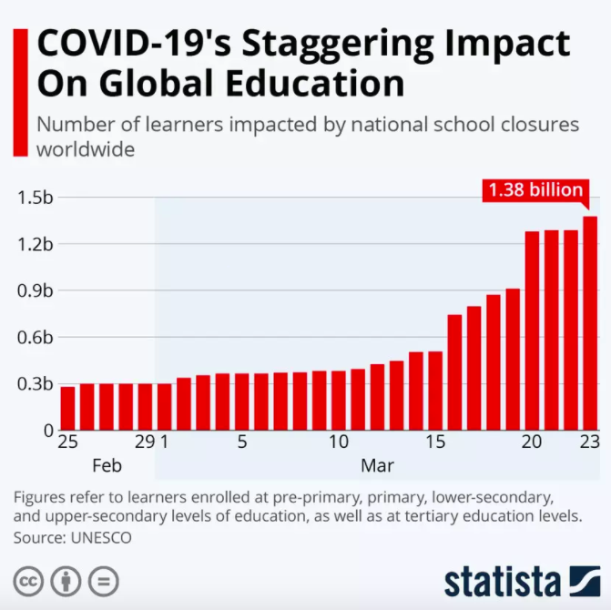

Figure 5: COVID’s impact on global education (collected from World Economic Forum)

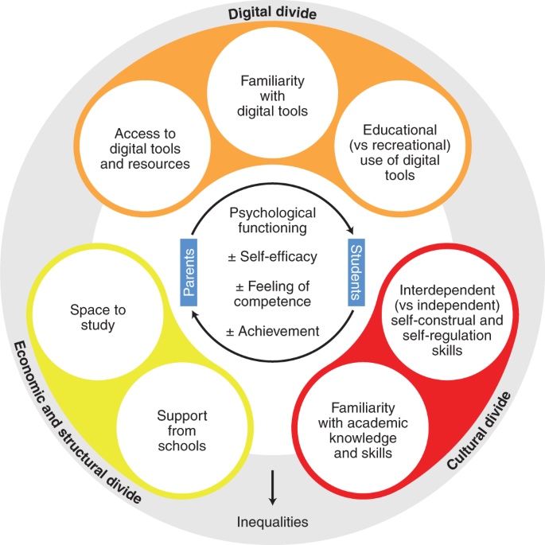

Figure 6: Social inequality processes during school closure (collected from Research Gate)

# **4.3 Lifecycle Analysis**

The DSRM method was chosen to present the concept. This method consists of six stages, including identifying problems and motivating, defining objectives of a solution, design and development, demonstration, evaluation, and communication. E-Learning includes in-classroom or out-of-classroom instruction, as well as the use of computers and the internet. E-learning is described as offering training and development to students and employees using electronic media such as the internet, audio, video, and so on. E-learning, often known as electronic learning or virtual learning, refers to web-based learning. People nowadays prefer to use the internet to get answers to their questions rather than going to the library or asking someone. As a result, the Importance of E-Learning in Education has grown.

E-Learning has become an essential tool for tutors from around the world. Earlier, access to knowledge was not possible for all. Geographical barriers have made travel to other nations difficult for professors and students. This new practice has aided in ensuring that students get consistent instruction. Learners and instructors benefit from increased cooperation and worldwide possibilities provided by e-learning. Tutors may make money by designing and selling courses using numerous online sites and applications, such as (Digital Class World; Android App). Teachers are given extensive assistance in developing and marketing their practices.

In addition, the wages are pretty significant, which may make it possible to transform studying into a full-time profession. Students may pick and select whatever categories or subjects they wish to learn about.

Chegg, Vedantu, and others are examples of such websites. All of these applications or websites were created with instructors and students in mind.

The relevance of e-learning education cannot be overstated in today's digital environment. The modern form of remote teaching is web-based learning and virtual classrooms. As a result, it is reasonable to conclude that e-learning education should be adopted by a growing number of individuals.

Identification and motivation of the problem: This activity outlines the research challenge in detail and argues the importance of a solution. Justifying the value of a solution serves two purposes: it drives the researcher and the research audience to seek the resolution, and it allows the audience to appreciate the researcher's knowledge of the issue. This task requires awareness of the current condition of the problem and the significance of its resolution.

Define the solution's goals: The issue description and knowledge of what is conceivable and doable may be used to infer the purposes of a solution. The goals might be quantitative, such as phrases that describe how the desired solution would be better than present ones, or qualitative, such as a description of how a new artifact is intended to assist answers to issues that have not been addressed before. The goals should be logically deduced from the problem description.

Development and design: There is the creation of an artifact. A DSR artifact may theoretically be any constructed thing that incorporates a research contribution. This activity includes identifying the required functionality and architecture of the artifact, as well as building the item itself.

Demonstration: This exercise explains how the artifact may be used to address one or more problems. This might include using it in experiments, simulations, case studies, proofs, or other relevant activities.

Evaluation: The assessment assesses how effectively the artifact contributes to a problem-solving solution. This activity entails comparing a solution's aims to actual observable outcomes from the artifact's usage in context. The evaluation may take different shapes depending on the nature of the issue and the artifact. At the conclusion of this activity, the researchers may choose whether to return to step three to increase the artifact's efficacy or to go on to communication and leave further development to future initiatives.

Communication: The relevant stakeholders are informed about all parts of the challenge and the intended artifact. Depending on the study aims and the audience, such as practicing professionals, appropriate modes of communication are used.

# **4.4 Solution Verification**

One of the most significant deterrents to online retention is the overestimation of pupil talents with appreciation to the needs of the time, commitment, and technological skills required in online gaining knowledge. One manner to address this is thru orientation packages that introduce college students to the pains and particular needs of the net classes. However, that itself may be a task. Studies performed by (Bozarth, Chapman, and LaMonica, 2004) screen the want for designers and facilitators to recognize that college students' personal perceptions or misconceptions in their technological talents turn into the most important task because it makes college students sense that an internet orientation software isn't required. As a result, many college students display resistance to what they understand as a useless intervention to their direction penetration. Instead of feeling pissed off with this attitude, teachers and establishments need to reflect on consideration on techniques to be able to implement orientation, as opposed to making it obligatory. Instructors must additionally examine their personal technological, communication, and facilitation talents and try to replace them if necessary. (Muirhead, 2004) Recommends that teachers increase techniques to be able to beautify their steering for the college students, along with growing a timeline for comments and having a particular comments rubric. This may also mitigate the warfare instructor's face whilst looking to set up a significant presence of their online classes. This may additionally facilitate the teachers' personal discovery and experimentations to increase techniques for a continuing collaboration with and among the college students. In addition, this Pandemic (COVID-19) has altered the methods of coaching and gaining knowledge perpetually. Therefore, earning ability has changed significantly, with the large boom of e-gaining knowledge. Even earlier than COVID-19, there has been a rapid increase and recognition of instructional technology.

Literature opinions additionally assist that improving the social subculture of an e-Learning is going a protracted manner in permitting college students to keep with their e-learning and entire their education. . Consequently, online guides must be designed to foster extra social interplay among friends and college students-teachers.

* **Comparing your research findings with the results of other existing published studies:** Pupils ought to be compelled to review regarding the e-learning techniques. Organizations got to manufacture a specific IT unit to want care of all the technical issues involving e-learning. E-learning is assigned into complete learning and blended learning, subject to the use of the technique as either an extension of the face-to-face education. Simply just in the case of comprehensive e-learning, face-to-face contact isn't necessary. However, in the case of homogenized quite e-learning face to face contact is required. For blended e-learning, each face-to-face and online learning is utilized from time to time.

(Dhir, S. K.; Verma, D.; Batta, M.; Mishra, D., October 15, 2017.)

* **Flexibility and comfort of entree:** E-studying isn't static or well-timed excessive pleasant to a selected timetable. It's clean to reach. As a result, college university college students may want to probably get the right of gaining entry to it every time and from anywhere. Instructors can also furthermore enhance and manipulate the educational contents every time they need (Chu LF, Chan BK, (1998).) The delivery of the content material cloth via molecular furthermore dietary nutritional dietary supplements this feature (Goldsworthy S, Lawrence N, Goodman W., 2006).
* **Numerous natures:** E-studying is sans borders. It's valuable in isolated/far-off villages

similarly. The novices will essentially be from any vicinity of the globe

(Naing C, Wai VN, Durham J, Whittaker MA, Win NN, Aung K, et al., 2015)

* **Time-saving**: many learners are going to be engaged at an equivalent time, thus decreasing the time required for the program. The material, once prepared, is everlasting and maybe re-examined several times. The saved time in making materials is additionally used by the instructors to spice up their advanced level of intellectual e-learning (Toumas M, Basheti IA, Bosnic-Anticevich S. Z., 2009)
* **Adult getting to know values:** E-getting to know assists in gaining statistics in-depth, escalates self-motivation, and accomplishes the grownup getting to understand values. (Qureshi IA, Ilyas K, Yasmin R. Whitty M., 2012). . Likewise, it lets newbies decide their personal getting to know methods. It's customized to learner's needs, accordingly assisting in self-reliant getting to know (Al-Shorbaji N, Atun R, Car J, Majeed A, Wheeler E (eds), 2015)
* **Uniformity:** As the equal fabric is provided to all of the newbies, the curricula' consistency is preserved throughout the newbies. The newbies who resided off campuses got analogous substances. This assists inside the regular accomplishment of getting to know dreams due to the same accessibility of high-satisfactory and quantity of substances disseminated (Dhir, S. K.; Verma, D.; Batta, M.; Mishra, D., 2017)

The technical arrangement (i.e., hardware and code) is essential for an e-learning platform. (Randell D., 2001). A 24/7 entree at each field and off-campus is important for e-learning to be effective (Childs S, Blenkinsopp E, Hall A, Walton G., 2005). The accomplishment of e-learning depends on adequate net affiliation (Yeung JC, Fung K, Wilson TD, 2012). There are money problems for fixing, operational, and maintenance of the e-learning platform. The confidentiality and safety of knowledge have to be compelled to be preserved. With the growing virtual world, cybercrimes also are mounting. As a result, identity management needs to be handled effectively and expeditiously (Alves P, Uhomoibhi J., 2016). Fashionable antivirus software, similarly to operating systems, is also required. To keep up the high normal of e-learning programs, establishments have to be compelled to have an adequate variety of employees (Al-Shorbaji N, Atun R, Car J, Majeed A, Wheeler E (eds), June 05, 2020). It's crucial to possess enough support staff to sustain the dynamic conditions of e-learning. Technical Support: In several institutions, there's not enough mechanical backing to control e-learning programs properly though they will possess sensible infrastructure (Hadley J, Kulier R, Zamora J, Coppus SFPJ, Weinbrenner S, Meyerrose B, et al., 2010). The absence of direct interactions is one of the most critical challenges of e-learning. The deficiencies of tutor support, notably just in the case of the complicated subjects, were quoted as a downside of e-learning (Gerdprasert S, Pruksacheva T, Panijpan B, Ruenwongsa P., 2011). Psychological matters: each academic and learner feel stressed concerning e-learning chiefly once good pointers are not pronto obtainable. The necessity of information for understanding the notions of the powerful subject makes students a lot cynical. Predominant myths regarding e-learning can spoil the learners (Harden RM., 2002). Varied researchers know that language could be a hurdle in the execution of e-learning (Jeffries PR, Woolf S, Linde B., 2003). The same ancient learning, the rules in e-learning are delivered in English, which might be a challenge for learners who aren't snug with the foreign language.

Tools of data collection: A semi-tailored electronic form was used and contained four parts:

**First part:** queries on socio-demographic and activity data of the participants as age, gender, marital status, residence, work sector (academic or clinical), current employment status, years of teaching expertise, whether or not they have schooled a web course before or not, and their experience duration.

**Second part:** questions on university employees' perceptions and experiences of online courses custom-made from a previous study (Totaro M, Tanner J, Noser T, Fitzgerald J, Birch R., 2005;). The questions are rated on a scale starting from powerfully disagree to strongly agree by that the employee may be specific their agreement levels.

**Third part:** queries on barriers and challenges towards online learning. Medical employees ought to rank the challenges facing distance education so as to their seriousness (Mutisya D, Makokha G., 2016;).

**Fourth part:** questions supported the valid Technology Acceptance Model (TAM) (Gahtani SA., 2001;) for exploring factors that have an effect on university medical staff acceptance and use of e-learning as a teaching tool. It consisted of 3 things, particularly perceived usefulness, perceived easy use, and acceptance on a five-point scale starting from ''strongly disagree" to ''strongly agree." acceptance was categorized as settle for and don't accept in step with the median (median = 2.5), scores higher than 2.5 indicate acceptance whereas rated scores <2.5 indicate refusal.

Data analysis techniques used for detection of the share of respondents’ response is delineated very well within the work of Napitupulu et al. (Napitupulu D, Simarmata J, Abdillah LA, Setiawan MI, Ahmar AS, Rahim R, et al., 2018;)

# **CONCLUSION**

The main focus of our thesis paper was the effectiveness of e-Learning. The main objective of our research was to utilize the efficient way to learn through e-Learning in Pandemic. We have discussed the challenges teachers and students face and researched the topic. We conducted a survey to collect data where the students were provided with polls where they were asked to agree or disagree to points provided about the problems and satisfaction of using e-Learning. They were asked if they were satisfied enough and had learned as much as they would have in offline classes and whether the teachers and institutions were helpful and considerate. Based on the results collected from the survey, we tried to provide solutions to make the e-Learning process and system more effective than before. As we performed only one method of data collection, future researchers can extend the study by further research and provide alternate solutions to what has been already given.

# **REFERENCE**

Al-Shorbaji N, Atun R, Car J, Majeed A, Wheeler E (eds) (2015). E-learning for undergraduate health professional education- a systematic review informing a radical transformation of health workforce development. Retrieved from: HTTP:// whoeducationguidelines.org/content/e-learning-report

Alves P, Uhomoibhi J. (2016). Online Experimentation: Emerging Technologies and IoT

Bozarth, Chapman, and LaMonica (2004). Preparing for Distance Learning: Designing An Online Student Orientation Course, 7(1): 87-106.

Childs S, Blenkinsopp E, Hall A, Walton G. (2005). Effective e-learning for health professionals and students - barriers and their solutions. Health Inf. Library Journal. Vol. 22, pages 20-32.

Chu LF, Chan BK (1998). Evolution of website design: implications for medical education on the internet. Retrieved from <https://www.sciencedirect.com/science/article/abs/pii/S0010482598000274>

Dhir, S. K.; Verma, D.; Batta, M.; Mishra, D. (2017). E-Learning in Medical Education in India

Elena R. V., Anna V. M., Suriya I. G., Evgeniy M. D., Vladimir V. E. (2020)  Present-day management of universities in Russia: Prospects and challenges of e-learning.

Gahtani SA. (2001). The Applicability of TAM Outside North America: An Empirical Test in the United Kingdom. Information Resource Management Journal

Gerdprasert S, Pruksacheva T, Panijpan B, Ruenwongsa P. (2011), An interactive web-based learning unit to facilitate and improve intrapartum nursing care of nursing students.

Gilbert, Morton, & Rowley (2009). E-Learning: The student experience. Retrieved from <http://www.blackwell-synergy.com/>

Goldsworthy S, Lawrence N, Goodman W. (2006). The use of personal digital assistants at the point of care in an undergraduate nursing program.

Govindasamy (2002). Successful implementation of e-Learning. The Internet and Higher Education, 4(3-4), 287-299.

Guribye, F. and Netteland, G. (2003). Representations of knowledge in infrastructures for learning and networked. Retrieved from <https://brill.com/view/book/9789460910074/BP000007.xml>

Hadley J, Kulier R, Zamora J, Coppus SFPJ, Weinbrenner S, Meyerrose B, et al. (2010). Effectiveness of an e-learning course in evidence-based medicine for foundation training. J R Soc Med. Vol. 13, Page: 288-294

Harden RM. (2002). Learning outcomes and instructional objectives: is there a difference? Medical Teacher, Vol. 24, No. 2, 2002, 151–155

Hasan (2021). Ontology-Based Framework for E-Government Regulatory Requirements Compliance. Retrieved from <https://estia.hua.gr/file/lib/default/data/25278/theFile>

Hevner & Chatterjee (2010). Design Science Research in Information Systems.

Jeffries PR, Woolf S, Linde B. (2003). TECHNOLOGY - BASED vs. Traditional Instruction: A Comparison of Two Methods for TEACHING the Skill of Performing a 12-Lead ECG. Volume 24 - Issue 2 - p 70-74

Lee & Yoon (2009). Learners’ acceptance of e-learning in South Korea: Theories and results. Computers & Education, 53(4), 1320–1329. Retrieved from <https://doi.org/10.1016/j.compedu.2009.06.014>

LeePost, (2009). e-Learning Success Model: An Information Systems Perspective. Volume 7 Issue 1 2009, (pp61 - 70). Available at [www.ejel.org](http://www.ejel.org).

Molla & R. (2020). How coronavirus could force the work-from-home movement.

Muirhead (2004). The Effects of Student Engagement, Student Satisfaction, and Perceived Learning in Online Learning Environments. Available at <https://files.eric.ed.gov/fulltext/EJ1103654.pdf>

Mutisya D, Makokha G. (2016). Challenges affecting adoption of e-learning in public universities in Kenya. E-Learning and Digital Media.

Naing C, Wai VN, Durham J, Whittaker MA, Win NN, Aung K, et al. (2015). A systematic review and meta-analysis of medical students' perspectives on the engagement in research.

Napitupulu D, Simarmata J, Abdillah LA, Setiawan MI, Ahmar AS, Rahim R, et al. (2018). Analysis of Technology Acceptance Model (TAM) on E-Learning System.

Ozkan & Koseler (2009). Multi-dimensional students’ evaluation of e-learning systems in the higher education context: An empirical investigation. Computers & Education, 53(4), 1285–1296. Retrieved from <https://doi.org/10.1016/j.compedu.2009.06.011>

Peffers et al. (2006). The design science research process: A model for producing and presenting information systems research.

Peffers et al. (2007). A design science research methodology for information systems research. Journal of Management Information Systems 24(3):45-77

Qureshi IA, Ilyas K, Yasmin R. Whitty M. (2012). Challenges of implementing e-learning in a Pakistani university. Knowledge Management E-Learn Int. 2012; 4:310-24.

Randell D. (2001) E-learning for continuing education: exploring a new frontier. Med Lab Obs. 2001; 33:24-8.

Rosenberg (2001), (p. 28). E-Learning: Strategies for Delivering Knowledge in the Digital Age. McGraw-Hill, New York.

Rosenberg (2001), (p. 30). E-Learning: Strategies for Delivering Knowledge in the Digital Age. McGraw-Hill, New York.

Totaro M, Tanner J, Noser T, Fitzgerald J, Birch R. (2005). Faculty Perceptions of Distance Education Courses: A Survey. Journal of College Teaching & Learning.

Toumas M, Basheti IA, Bosnic-Anticevich S. Z. (2009). Comparison of small-group training with self-directed internet-based training in inhaler techniques.

Wang & Shee (2007). Measuring e-Learning Systems Success in an Organizational Context: Scale Development and Validation. Computers in Human Behavior, 23, 1792-1808. Retrieved from <https://doi.org/10.1016/j.chb.2005.10.006>

Yeung JC, Fung K, Wilson TD (2012). Prospective evaluation of a web-based three-dimensional cranial nerve stimulation. J Otolaryngol Head Neck Surg. 2012; 41:426-36.

Yoon, J., Yang, E., Lee, J. and Hwang, S. J. (2017). Lifelong Learning with Dynamically Expandable Networks. Retrieved from https://arxiv.org/abs/1708.01547

# **APPENDIX**

The survey questionnaire is shown below, along with the responses:

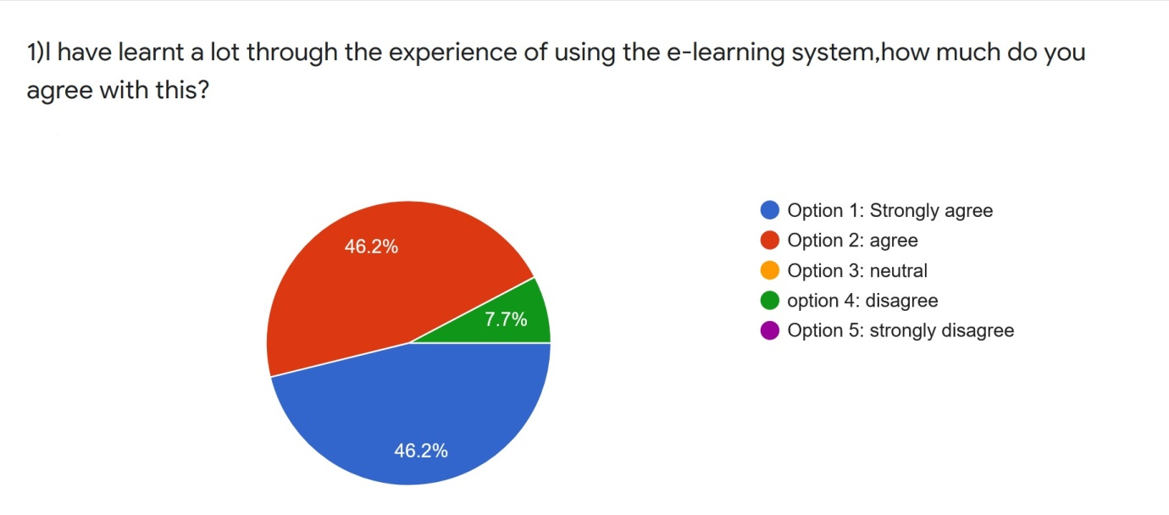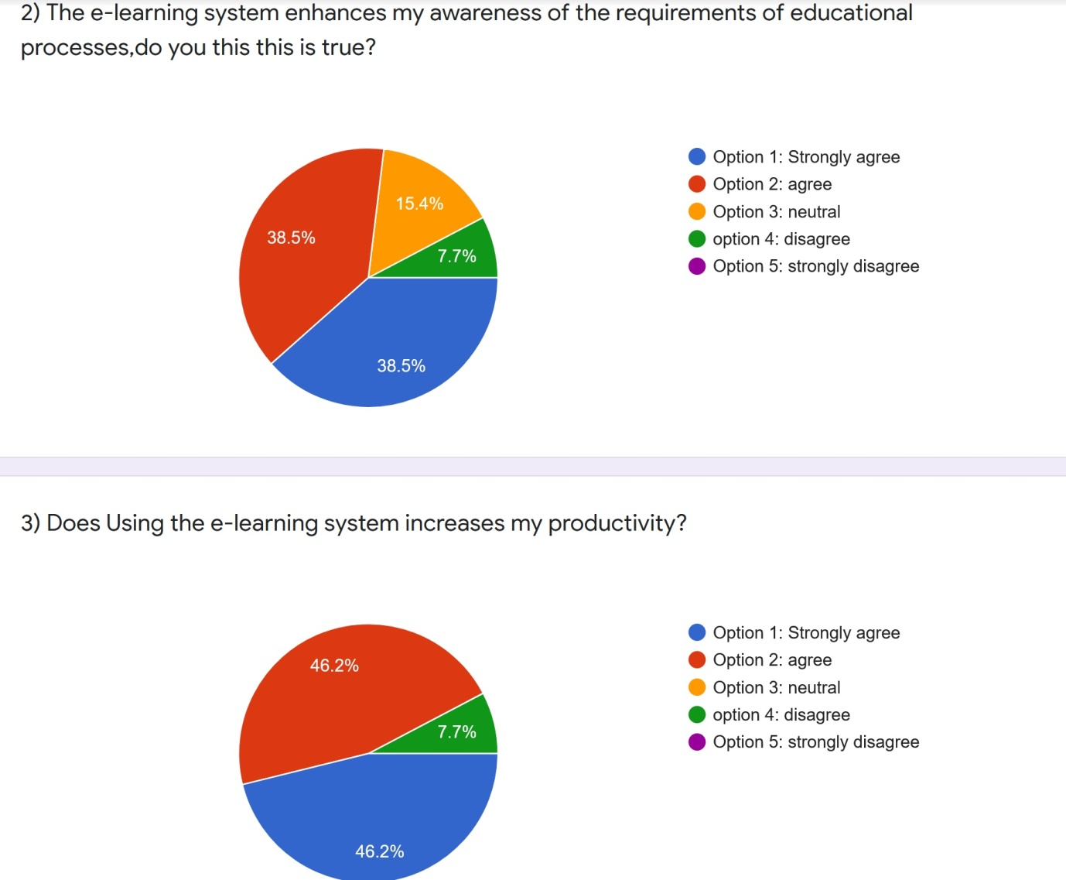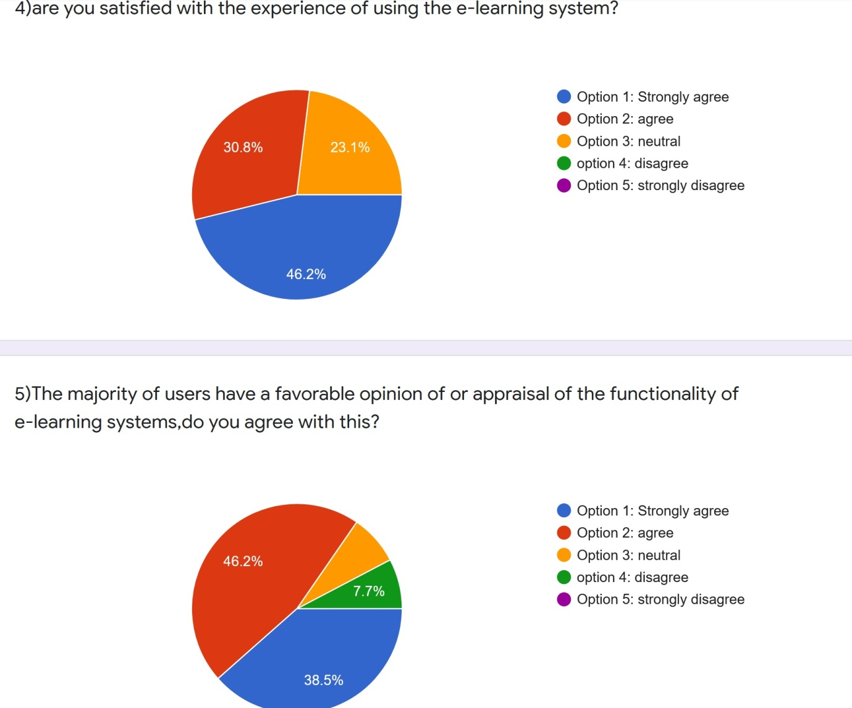

Figure 7: Survey questionnaire and response